**PROJECT Description:**

We are preparing to do this project for the sake of users who is more interested in movies. Name of our project is **MOVIE DATABASE**. This project is about to search the movie details. It basically consists of following details mentioned below…

1. Adding the movie name into **MOVIE** database , when the new movie comes.
2. Updating the movie details when the get update.
3. Our movie details consists of :

**1. Movie name**

**2. Hero name**

**3. Heroine name**

**4. Director name**

**5. Release date**

**6. Movie category**

**7. Movie industry**

**8. AA Rating**

**9. Movie budget**

**4**. **Used modules**:

At first we have to set up a connection between **mysql** and **python** by using a module **mysql.connector** then we define some functions. We use **clrprint** module for output to get different colours and it also attract interface.

**5**. **Admin related functions**:

**1. To add movie details-** This is a admin related function to run this function we use a **password** for our security purpose.it is very easy to add a movie in our database. First it asks details, admin enters then after all details entered its get added. If any detail not entered by admin it take as **NULL** value. For example sometimes released date of a movie not confirmed then we enter as a null value.

**2. To update movie details-** This is also a admin related function which is used for correction if any mistake is typed and also changing some dates. For example sometimes released date get delayed and get postponed for other date then we have to update it.

**6. User related funcions:**

**1.To search a movie-** This is user related function which is used to search their movie. User can search anything about movies and we have classified into different categories those we have mentioned above. User can search by their interest. User can search by movie or hero or heroine etc…

**Source code:**

***#to connect mysql with python***

***import clrprint***

***from clrprint import \****

***import mysql.connector as mc***

***mycon=mc.connect(host='localhost',user='root',passwd='password',database='MOVIE')***

***cur=mycon.cursor()***

***#to add something***

***def add():***

***m_id=int(input('enter movie ID-'))***

***mov=input('enter movie name-')***

***if mov==None:***

***mov="Null"***

***hero=input('enter hero name-')***

***if hero==None:***

***hero="Null"***

***heron=input('enter heroine name-')***

***if heron==None:***

***heron="Null"***

***dirt=input('enter director name-')***

***if dirt==None:***

***dirt="Null"***

***year=input('enter movie released date(__-__-____)-')***

***if year==None:***

***year="Null"***

***cat=input('enter movie category-')***

***if cat==None:***

***cat="Null"***

***ind=input('enter movie industry-')***

***if year==None:***

***year="Null"***

***rating=float(input('enter movie AA_rating-'))***

***if rating==0:***

***rating="Null"***

***budg=input('enter movie budget-')***

***if budg==None:***

***budg="Null"***

***add="insert into movie_details values({},'{}','{}','{}','{}','{}','{}','{}',{},'{}')".format(m_id,mov,hero,heron,dirt,year,cat,ind,rating,budg)***

***cur.execute(add)***

***clrprint("ADDED SUCCESSFULLY",clr='g')***

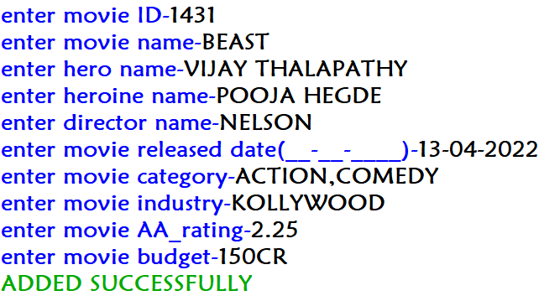

***mycon.commit()***

***#to update something***

***def update():***

***prk=int(input("enter primary key value"))***

***att=input("enter attribute name")***

***val=input("enter updated value")***

***upd="update movie_details set "+att+"='{}' where movie_id={}".format(val,prk)***

***cur.execute(upd)***

***clrprint("UPDATED SUCCESSFULLY",clr='g')***

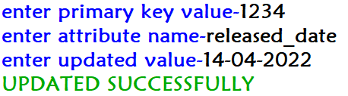

***mycon.commit()***

***#to search anything***

***def search():***

***clrprint("PRESS 1 TO SEARCH MOVIE NAME \nPRESS 2 TO SEARCH HERO NAME\nPRESS 3 TO SEARCH HEROINE NAME\nPRESS 4 TO SEARCH DIRECTOR NAME\nPRESS 5 TO SEARCH YEAR \nPRESS 6 TO SEARCH CATEGORY \nPRESS 7 TO SEARCH INDUSTRY \nPRESS 8 TO SEARCH RATING ",clr='i')***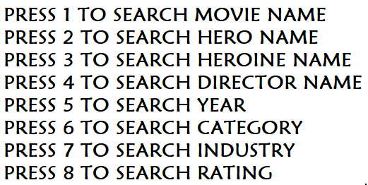

***ch=int(input('ENTER YOUR CHOICE TO CONTINUE-'))***

***if ch==1:***

***sm=input('ENTER MOVIE NAME TO SEARCH-')***

***movie='select * from movie_details where movie like "%{}%"'.format(sm)***

***cur.execute(movie)***

***data=cur.fetchall()***

***for row in data:***

***clrprint('MOVIE_NAME-',row[1],'\nHERO_NAME-',row[2],'\nHEROINE_NAME-',row[3],'\nDIRECTOR_NAME-',row[4],'\nYEAR_RELESED-',row[5],'\nCATEGORY-',row[6],'\nINDUSTRY-',row[7],'\nAA_RATING-',row[8],'\nBUDGET-',row[9],clr="p,y,p,y,p,y,p,y,p,y,p,y,p,y,p,y,p,y,p,y,p,y,p,y,",end='\n\n')***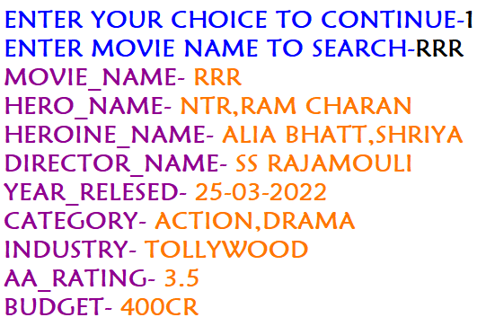

***mycon.commit()***

***if ch==2:***

***sh=input("ENTER HERO NAME TO SEARCH-")***

***hero='select movie from movie_details where hero like "%{}%"'.format(sh)***

***cur.execute(hero)***

***data=cur.fetchall()***

***clrprint("MOVIES OF YOUR HERO:",sh,clr="g")***

***for row in data:***

***clrprint(row[0],clr="y")***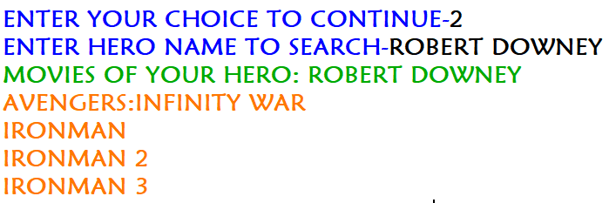

***mycon.commit()***

***if ch==3:***

***she=input('ENTER HEROINE NAME TO SEARCH-')***

***heroine='select movie from movie_details where heroine like "%{}%"'.format(she)***

***cur.execute(heroine)***

***data=cur.fetchall()***

***clrprint("MOVIES OF YOUR HEROINE:",she,clr="g")***

***for row in data:***

***clrprint(row[0],clr='p')***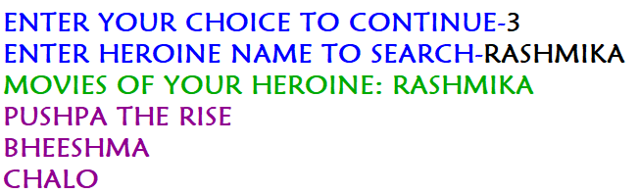

***mycon.commit()***

***if ch==4:***

***sd=input("ENTER DIRECTOR NAME TO SEARCH-")***

***director='select movie from movie_details where director like "%{}%"'.format(sd)***

***cur.execute(director)***

***data=cur.fetchall()***

***clrprint("MOVIES OF YOUR DIRECTOR:",sd,clr="g")***

***for row in data:***

***clrprint(row[0],clr='y')***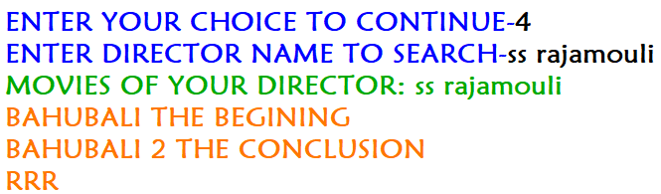

***mycon.commit()***

***if ch==5:***

***sy=input("ENTER YEAR/DATE/MONTH TO SEARCH-")***

***year='select movie,released_date from movie_details where released_date like "%{}%"'.format(sy)***

***cur.execute(year)***

***data=cur.fetchall()***

***for row in data:***

***clrprint('MOVIE-',row[0],'-',row[1],clr='g,y,r')***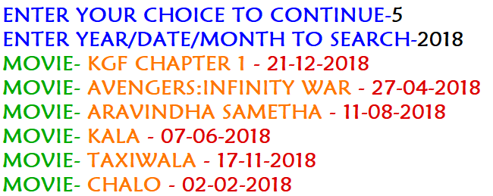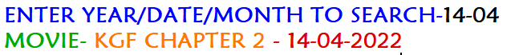

***mycon.commit()***

***if ch==6:***

***sc=input("ENTER CATEGORY TO SEARCH-")***

***cate='select movie from movie_details where category like "%{}%"'.format(sc)***

***cur.execute(cate)***

***data=cur.fetchall()***

***clrprint('SEARCHED CATEGORY MOVIES ARE:',clr='r')***

***for row in data:***

***clrprint(row[0],clr='y')***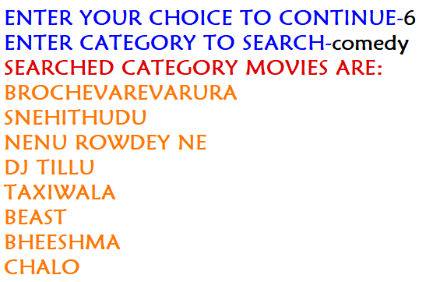

***mycon.commit()***

***if ch==7:***

***si=input("ENTER INDUSTRY TO SEARCH-")***

***indy='select movie from movie_details where industry like "%{}%"'.format(si)***

***cur.execute(indy)***

***data=cur.fetchall()***

***clrprint('SEARCHED INDUSTRY MOVIES ARE:',clr='r')***

***for row in data:***

***clrprint(row[0],clr='y')***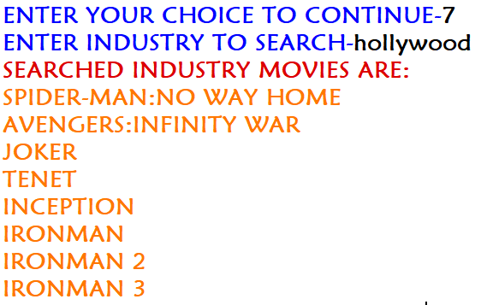

***mycon.commit()***

***if ch==8:***

***sr=float(input("ENTER RATING TO SEARCH-"))***

***ratg='select movie,aa_rating from movie_details where aa_rating>={}'.format(sr)***

***cur.execute(ratg)***

***data=cur.fetchall()***

***clrprint('THE MOVIES ARE AS FOLLOWS',clr='r')***

***for row in data:***

***clrprint(row[0],row[1],clr='g,y',sep='-')***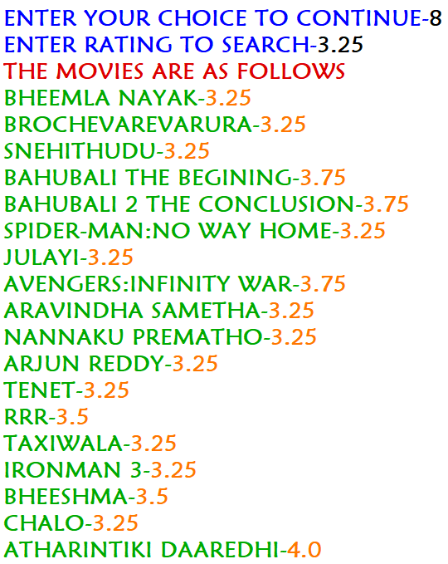

***mycon.commit()***

***# main program***

***while True:***

***print("WELCOME\nPRESS 1 TO ADD \nPRESS 2 TO UPDATE \nPRESS 3 TO SEARCH")***

***uc=int(input("ENTER YOUR CHOICE TO CONTINUE-"))***

***if uc==1:***

***psd=input("ENTER USER PASSWORD-")***

***if psd=='0000':***

***add()***

***elif uc==2:***

***update()***

***elif uc==3:***

***search()***

***else:***

***clrprint("ENTER A VALID CHOICE",clr=’r’)***

***fc=input("DO YOU WANT TO CONTINUE(Y/N)-")***

***if fc=='n' or fc=='N':***

***break***

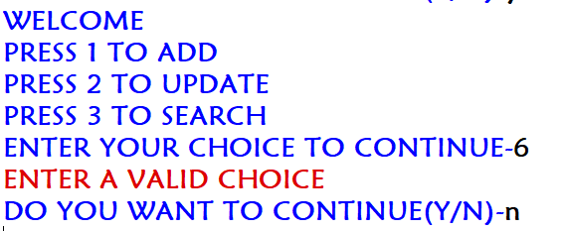

**CONCLUSION**

The project entitled “**MOVIE DATABASE**” has been proposed to be implementing in the place of manual system. We had made this project user-friendly by the use of various modules and database .This project eases to know the details of movie they searched. We are thankful to our subject teacher **SRIRAJ** sir, P.G.T computer science to boost up us to work on this project.

**REFERENCES**

**●** NCERT textbook class XII

**● www.google.com**

**●** [**www.wikipedia.org**](http://www.wikipedia.org)

**jawahar navodaya vidyalaya**

**SRIKAKULAM**

**INVESTIGATORY**

**PROJECT ON**

**MOVIE DATABASE**

DEPARTMENT OF COMPUTER SCIENCE

**NAME :** AKASH ARASADA

**CBSE NO : 20608914**

2021-2022

**jawahar navodaya vidyalaya**

**SRIKAKULAM**

**INVESTIGATORY**

**PROJECT ON**

**MOVIE Database**

DEPARTMENT OF COMPUTER SCIENCE

**NAME : ABHISHEK BODDA**

**CBSE NO : 20608893**

2021-2022

**CERTIFICATE**



This is to certify that **AKASH ARASADA**, a student of class XII  has successfully completed the investigatory project work titled **MOVIE DATABASE** under the guidance of **M.SRIRAJ, PGT COMPUTER SCIENCE** during the academic year 2021-2022 as part of **COMPUTER SCIENCE PRACTICAL EXAMINATION.**

**Signature of External Examiner**

**Signature of Internal Examiner**

**Signature of Principal**

**CERTIFICATE**



This is to certify that **ABHISHEK BODDA**, a student of class XII  has successfully completed the investigatory project work titled **MOVIE DATABASE** under the guidance of **M.SRIRAJ, PGT COMPUTER SCIENCE** during the academic year 2021-2022 as part of **COMPUTER SCIENCE PRACTICAL EXAMINATION.**

**Signature of External Examiner**

**Signature of Internal Examiner**

**Signature of Principal**

|  |  |  |
| --- | --- | --- |
|  |  |  |

**Acknowledgement**

I wish to express my deep gratitude and sincere thanks to the Principal, D.V. RAMANA sir, for his encouragement and for all the facilities that he provided for this project work.

I sincerely appreciate this mangnanimity by taking me into his fold for which I shall remain indebted to him. I extended my hearty thanks to MR. SRIRAJ sir, computer science teacher, who guided me to the successful completion of this project. I take this opportunity to express my deep sense of gratitude for his valuable guidance, constant encouragement, immense motivation, which has sustained my efforts at all the stages of this project work.

I can’t forget to offer my sincere thanks to project partner and all my classmates who helped me to carry out this project work successfully and for their valuable advice and support, which I received from them time to time…..

**Contents**

* Acknowledgement
* Project description
* Modules used
* Admin related functions
* User related functions
* Project overview
* Source code
* Outputs for the code
* Conclusion
* References